**Challenge 04 - SASS & Flex**

For this week’s challenge, you’ll need to create a gallery website full of images, using Flex & Sass. Refer to the *screenshots & video* folder to see the exact look of the page.

The menu on the left should be fixed. And every image is a link.

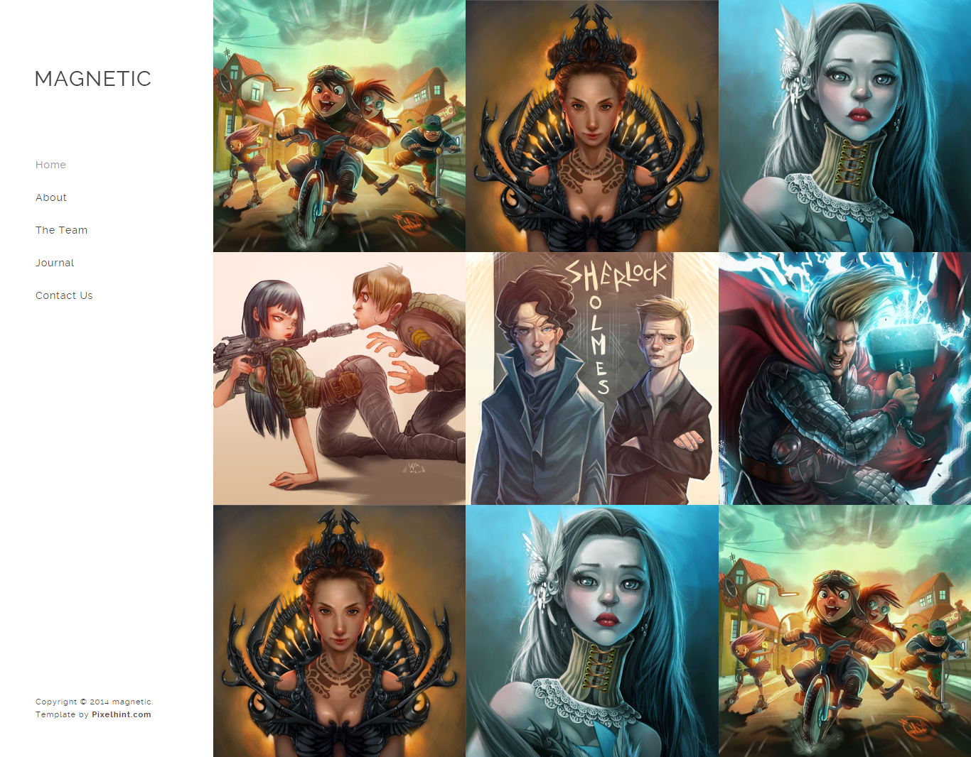

When the page is open in responsive mode (mobile and tablet), the sidebar menu should be switched to a hamburger menu.

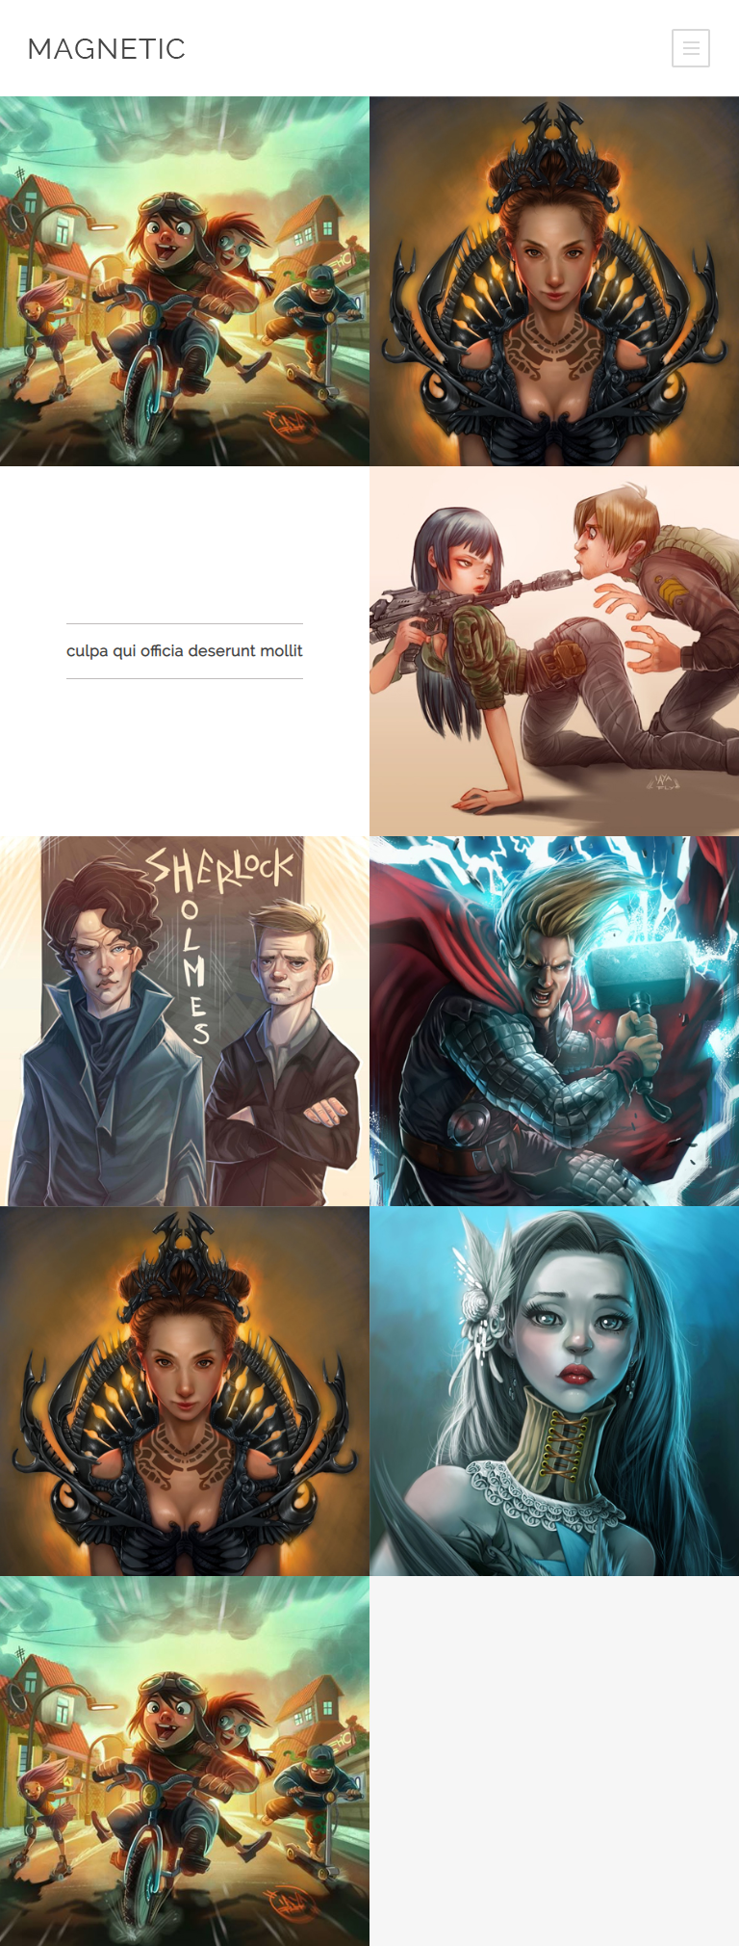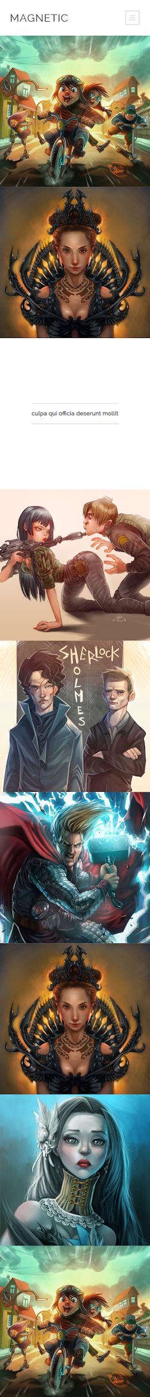

#### 

#### Evaluation system:

**1 point** - Whole page completed in HTML & CSS

**3 points** - Add all the hover effects & make the page responsive for mobile and tablet devices.

**5 points** - for using SASS instead of plain CSS

#### Deadline:

**1 week after its presentation, 23:59h end of the day.**

#### Hints:

* Use Flex to avoid any pain in positioning the elements.